**Ford Ka Case**

Brian Gillman, Sean Olson, Shawn Killpack, Andres Ruiz

MBA 706 - Data Analytics

**1. Which segment should they target? What segmentation strategy should Ford follow for the Ka brand?**

Using the data provided, a K-Means clustering method was used to separate three clusters. Figure 1 shows the elbow test that we used to determine that using three clusters provides the most per cluster. Moving to 4 clusters or higher adds complexity and confusion with minimal gain.

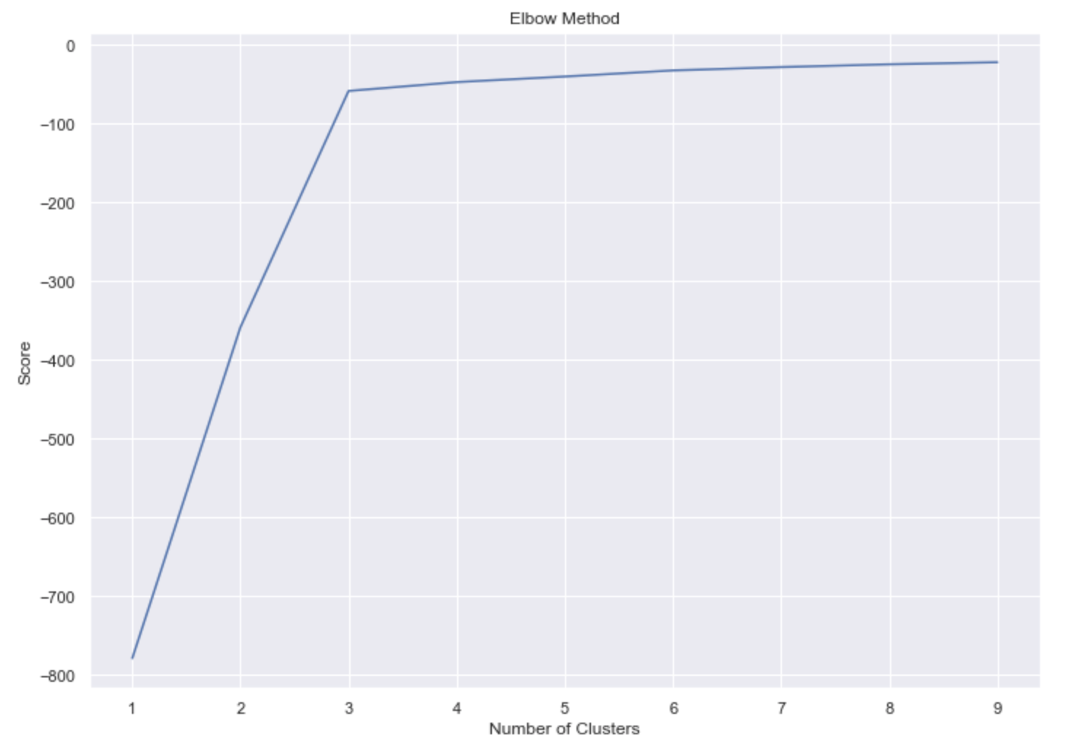

Figure 1: Elbow Test for K-Means Clustering of Data

The scatter plot in Figure 2 shows the grouping of each cluster.

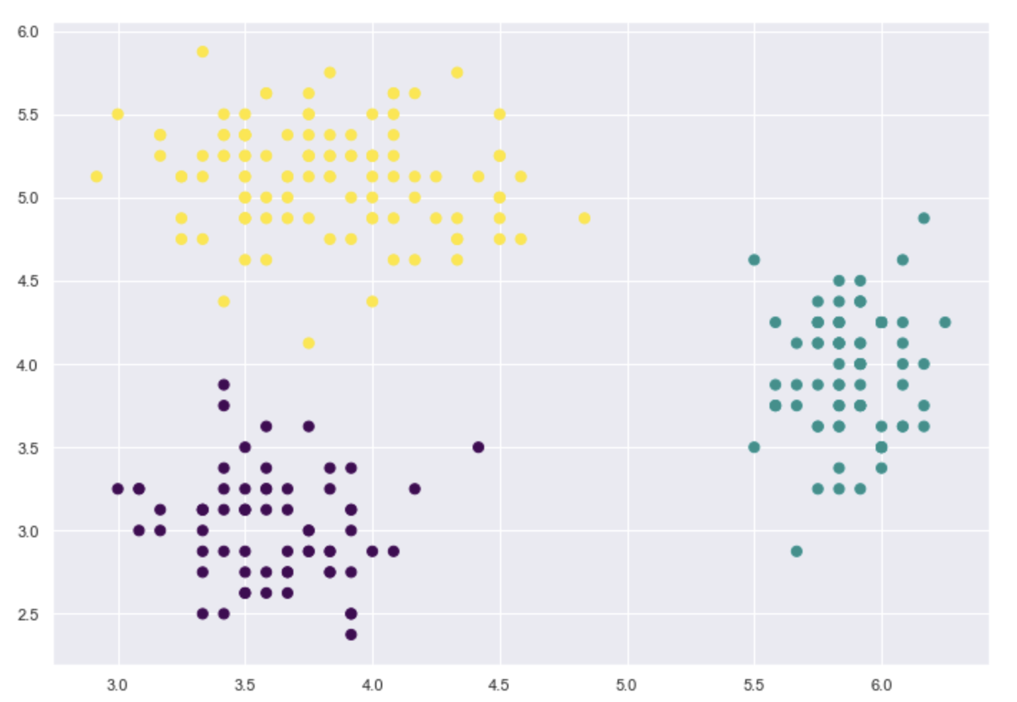

Figure 2: Scatter Plot of 3 Clusters

Table 1 shows the numbers and key values of each cluster:

|  |  |  |  |  |  |  |
| --- | --- | --- | --- | --- | --- | --- |
| **Clusters** | **Customers** | **Emotion Center** | **Idealism Center** | **Realism Center** | **Freedom Center** | **Reliability Center** |
| Mean |  | 4.4 | 4.2 | 4.3 | 4.2 | 3.9 |
| 1 | 65 | 3.60 | 3.03 | 5.62 | 4.02 | 3.90 |
| 2 | 78 | 5.88 | 3.95 | 3.50 | 3.40 | 3.54 |
| 3 | 107 | 3.81 | 5.14 | 4.17 | 4.91 | 4.11 |

In order to determine which segment to target, a probability analysis was done using a Bernoulli Trial with a baseline probability of 0.50. Then depending upon how each respondent answered and combined with their demographics an individual probability of purchase of was determined and factored into the random Bernoulli Trial generator to determine the expectation of purchase (1 if yes would be expected to buy, 0 if not). The logic, assumptions and outcomes per cluster are explained in Appendix 1.

The results of this probability analysis showed that Cluster 1 is the ideal cluster to target because there was a higher ratio of individuals within that cluster who have the expectation of purchasing the new Ford Ka. This makes sense with the clustering analysis done which shows that Cluster 1 also had the most significantly higher outcome for realism than the other two clusters. These are the individuals that should be targeted because they’re the pragmatists, the people with that median income level who aren’t looking to purchase expensive vehicles nor are they looking for anything too flashy. The Ford Ka is great on gas mileage, given the high fuel prices, and it’s maintenance costs are lower than some of the more luxury European brands. These factors make it a realistic vehicle for the realistic consumer.

**2. How should they position their new brand?**

Figure 3 shows the multidimensional scaling (MDS) map for respondents that rated the Ford Ka in their top 3 choices (Choosers).

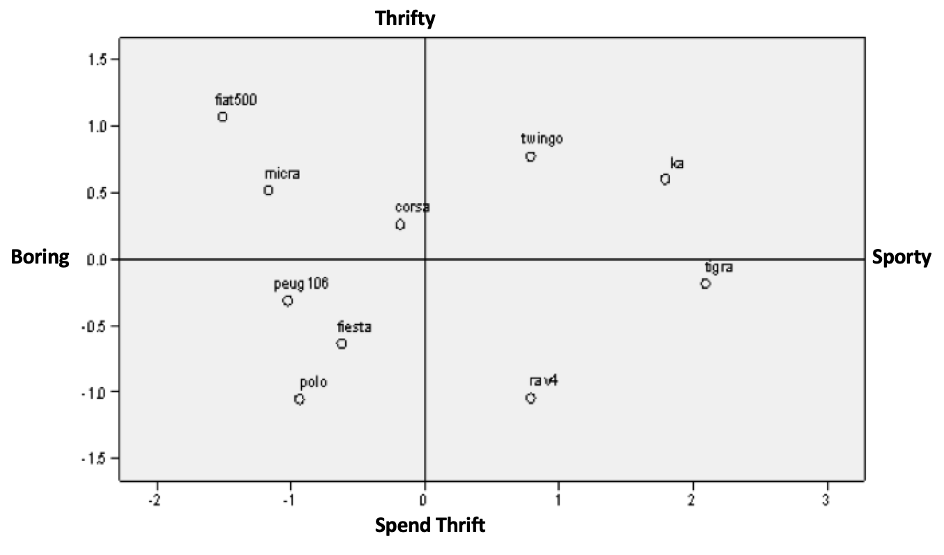

Figure 3, Choosers Multidimensional Scaling Map

The MDS map displays how the Ford Ka is positioned along two dimensions: sporty/boring and economical/spendthrift. As Figure 3 shows, choosers placed the Ford Ka closest to the Opel Tigra and Renault Twingo. Both the Tigra and Twingo have a sporty appearance and are have a purchase price below 65,000 and a road tax basis below 6. As a point of comparison, the RAV4, positioned in the lower right quadrant of the MDS is priced at 145,000 - 165,000 and has a road tax basis of 10.

Based on the MDS map, Ford should position the Ka as an economical, sporty car with modern features.

**3. Given what you have learned in the previous questions’ analyses:**

a. How should they price their product? The Ford Ka should be priced in the 60,000 to 65,000 range, similar to the Renault Twingo or Nissan Micra.

b. Describe an advertising campaign that might be used to target their segment.

The advertising campaign will demonstrate the Ford Ka as a futuristic and sophisticated vehicle with a sporty appearance. Additionally, the campaign will position the Ford Ka as an affordable yet trendy vehicle for the younger demographic who are currently budgeting to purchase a Tigra or Twingo. Furthermore, the campaign would also highlight the great gas mileage provided by the Ford Ka in comparison to other small car models. The ultimate goal of this campaign will be to differentiate the Ford Ka in the eyes of the 45% of respondents considered “choosers” who listed it as a Top 3 choice from its closest competitors in the Opel Tigra and Renault Twingo.

**Github Link to Analysis**

<https://github.com/oldmanoldson/DataAnalytics/blob/Homework-3/Analysis/FordKaCase_Homework3.ipynb>

**Appendix 1: Probability Analysis**

#### **Logic and Assumptions:**

* All percentages and weights will be derivations from 50% because this is the random chance probability of a binary outcome.
* Create percentages for the averages of the 5 attitudinal variables by dividing each number by 7 (the maximum average).
* Assign the following weights to each attitudinal variable based upon the case reading and perception of a small car:
  + **Preference Group:** Total weight = 60%; Breakdown: 0 (Non-Chooser) = 0%, 1 (Middle) = 40%, 2 (Chooser) = 60%
  + **Number of Children:** Total weight = 15%; 0-1 Children = 90%; 2-3 children = 10%; 4+ children = 0%
  + **Idealism:** Total weight = 7%
  + **Realism:** Total weight = 4%
  + **Gender:** Total weight = 4%; 0 (Female) = 75%, 1 (Male) = 25%
  + **Income Category:** Total Weight = 2%; 1-2 = 65%, 3-4 = 25%, 5+ = 10%
  + **Reliability:** Total weight = 2%
  + **Freedom:** Total weight = 2%
  + **Emotion, Age, Marital Status, 1st Time Purchase:** 1% weight for each; Age < 25 = 60%, Age 25 - 44 = 30%, Age > 45 = 10%; equal weights for Marital Status; 1st Time Purchase 0 (Not first car) = 40%, 1 (First car) = 60%

Cluster 1 Counts of Expected Purchase

-------------------------------------

0 38

1 27

Percentage of Respondents Expected to Purchase: 41.53846153846154%

Cluster 2 Counts of Expected Purchase

-------------------------------------

0 57

1 21

Percentage of Respondents Expected to Purchase: 26.923076923076923%

Cluster 3 Counts of Expected Purchase

-------------------------------------

0 69

1 38

Percentage of Respondents Expected to Purchase: 35.51401869158878%